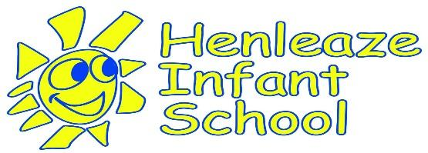

Home-School Partnership

Be kind, be curious, be you
Staff and parents work together towards fulfilling the school vision:
We firmly believe that if all members of the school community adhere to the Home School Agreement all children at Henleaze Infant School will benefit significantly. We therefore respectfully request that all parents/carers sign this agreement and to demonstrate their commitment to their child’s learning and to the school.

Parents/Carers will:
- Ensure that their child comes to school regularly, on time (8:50-3:20) and wherever possible, avoid term-time absences.
- Let the school know quickly of any concerns or problems that might affect their child’s learning and/or behaviour and support the school’s policies for behaviour and safeguarding.
- Behave in a way that reflects our school values of kindness, respect, curiosity and community and support your child to do the same.
- In partnership with the school, support their child’s learning, including attendance at parents’ evenings and curriculum information meetings.
- Ensure children attend appropriately dressed following the uniform policy and with appropriate outerwear and with their reading folder and PE kit
- Read school communications, including the class blog.
- Support the school by adhering to school policies (outlined on the school website)
- Supervise their child in the school grounds, recognising the use of any equipment is at your own risk

The school will:
- Provide a safe, welcoming environment, where all are included and valued, to ensure your child’s safety and happiness.
- Have high expectations for children’s learning and behaviour.
- Provide a balanced curriculum and high-quality teaching.
- Do all we can to meet the individual needs of your child.
- Communicate effectively, in regards to your child’s education and personal development and about important dates and events.
- Be open and welcoming to parents and encourage them to contribute to their child’s learning at home and at school.
- Respond promptly and fairly to any problems or concerns you may raise with us.

