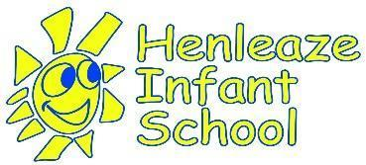
Henleaze Infant School
Anti-Bullying Procedures

Author/Person Responsible | Headteacher
Review Group | LGB
Review Frequency | Annually
Most recent Review | 9.12.24
Review Date | 13.12.25  Or sooner in line with national or trust policy change
Previous Review  Amendments/Notes | Policy changed to procedures and approach to sit under central CST Anti-bullying policy
Related Policies | Behaviour Policy  Safeguarding and Child Protection  RSE Policy (including online safety)

Be kind, Be curious, Be you
Kindness, Curiosity, Respect, Community
Rationale:
The procedures in this document are underpinned by our school values: kindness, curiosity, respect and community. We believe everyone at Henleaze Infant School has the right to feel welcome and safe and recognise that bullying can cause severe and adverse effects on children’s emotional well-being and mental health. By effectively preventing and tackling bullying our school can help to create a safe and disciplined environment, where pupils are able to learn and fulfil their potential. Our school is committed to actively working to prevent all forms of bullying and bullying behaviour and ensuring all members of the school community can thrive.

Aims:
- To ensure that all people (children and adults) in the school community are able to work in a safe, secure environment where everyone is treated with kindness and respect.
- To clarify for all members of the school community that bullying is not acceptable and will not be tolerated.
- To provide a framework to inform a proportionate response to bullying or bullying behaviour

Definition of Bullying:

Our children describe bullying as: “when someone is mean to you (says or does unkind things) again and again”

Bullying is defined as “behaviour by an individual or a group, repeated over time that intentionally hurts another individual either physically or emotionally”. (DfE Preventing and Tackling Bullying, July 2017)

The Anti-Bullying Alliance defines bullying as ‘the repetitive, intentional hurting of one person or group by another person or group where the relationship involves an imbalance of power’

At Henleaze Infant School we take a robust and proportionate response to bullying and bullying behaviour as a form of child on child abuse; recognising the age and emotional maturity of our pupils, as well as considering wider contextual factors, following a trauma informed approach.
We have a ‘zero tolerance’ approach to bullying and bullying behaviour. This means that we will respond proportionately to the individual circumstance of each case.

For details of the types of behaviours defined as bullying and the Cathedral School Trust-wide approach to tackling bullying please see the CST Anti-Bullying Policy on the policy page of our school website here.

Below are details of the age-appropriate approach and possible actions taken at Henleaze Infant School in the event of a report of bullying.

Actions to prevent bullying:
To reinforce our school vision and values and support pupils to develop their personal, social, emotional and moral education we will: :
- Raise awareness of the importance of positive relationships and inform children of the impact of bullying through the curriculum: via PSHE lessons, assemblies and support from adults in play.
- Through following the Kapow scheme of work which aims to support children to develop the personal and social skills of self-awareness, managing their feelings, empathy and social skills. Anti-bullying awareness will be explicitly taught during the Relationships and e-safety units as well as through a focus ‘Friendship Week’ each year .
- Openly discuss differences between people and tackle prejudices that could motivate bullying, such as: different family situations, SEND, religion, ethnicity, disability, gender, sexuality or appearance related difference.
- Recognise the potential for children with SEN and disabilities to be disproportionately impacted by bullying and implement additional pastoral support as required.
- Challenge practice and language (including ‘banter’) which does not uphold the school values of celebration, non-discrimination and respect towards others.
- Celebrate success and achievements to promote and build a positive school ethos

A school anti-bullying statement/charter has been written in consultation with the school council and is actively promoted in assemblies and shared with home.

Our Anti-Bullying charter:
At Henleaze Infant School we are kind to each other.
We respect each other’s differences and help to make sure everybody is happy by letting them join in our games.
We say “as long as your thoughts or actions are kind, they are welcome here”
If someone is unkind we say “stop it I don’t like it” and if they don’t, we tell an adult who can help us.
If we see someone being unkind we tell an adult.
Actions on report of bullying Flowchart:
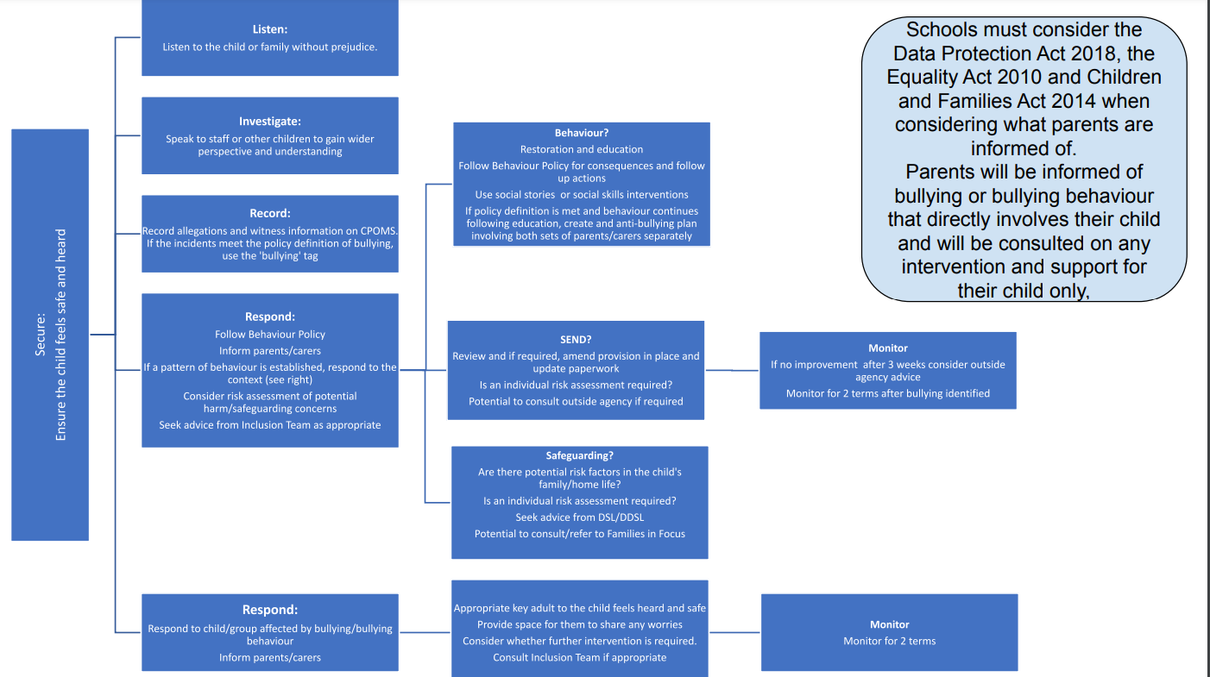

Link to full size document Anti Bullying Actions Flowchart here

