Henleaze Infant and Junior School Bulletin 

19th December 2025

Headteacher update:
Dear Parents/Carers
As we round up this first term of the year alongside the weariness felt, all of us were able to reflect back on the highlights of the year so far. From Reception children being very well settled and learning together as a well-established group, to Year 6s stepping up to host their WW2 experience afternoons to showcase their history learning in a myriad of ways.
Staff from both schools working together has become part of our routines and although the wet weather makes the trip between schools less pleasant, we have all benefitted from getting to know one another better and had positive outcomes from the collaboration.
Thank you for the gifts, cards and messages received. Staff and I are very grateful and will enjoy treats over the break. As well as this, many people have taken time to either speak to staff or send an email to say how much they and their children have enjoyed events and activities this term. This is also really appreciated as staff go above and beyond expectations to put these enrichment activities on.
As a final message, I’d like to draw your attention to the new Relationship and Sex Education Policy that is linked here and the date for the Junior School parent information meeting in the calendar section. The PSHE learning for the second half f next term include aspects within this topic. An Infant date will follow soon.
I hope you have a great break.
Kind Regards,
Gemma Fricker

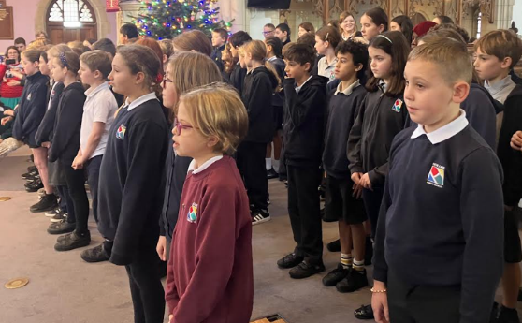
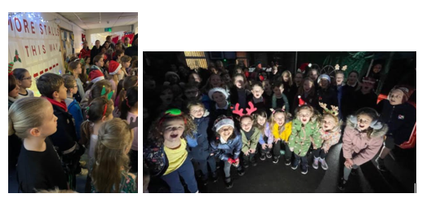
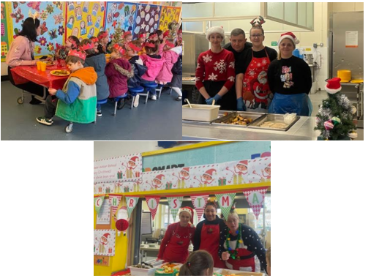
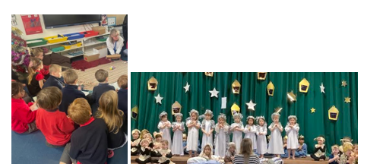
Highlights from the term!

Coming up:
Message from Henleaze Schools’ Governors

The Henleaze Schools’ new unified governing board brings together governors from both the Infants and Junior schools to provide joined-up strategic leadership, oversight and support, working closely with headteacher Gemma Fricker and staff to ensure the best possible education, wellbeing and outcomes for all pupils. We help oversee the school’s strategic direction, hold leaders to account, and ensure resources are used effectively in the interests of children and families.

We wish all parents, carers, pupils and staff a very happy and restful holiday period.

Both Schools:
Monday 5th January-INSET Day (school closed)

Infant School:

Junior School:
Monday 12th January 3:40 KS2 Sex and Relationships curriculum parent information session

Community spotlights

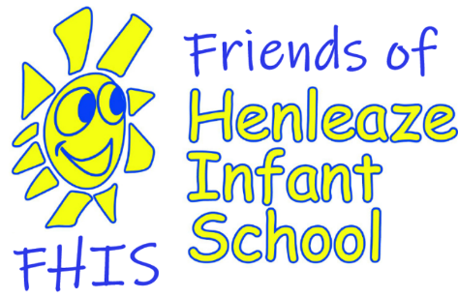   FHIS Quiz 2026 – Save the date  Save the date! Announcing the return of the renowned FHIS Quiz and Curry Night on Friday 13th March. Tickets will go on sale early January. You can join as team (max 8 players) or you can be allocated to one. Last year it was a sellout event, so don’t miss out! |   Christmas Bazaar success - £3,889 raised!  Thank you again everyone for supporting this fundraiser, be it running a stall, helping set-up, clear-up or spending on our stalls, raffle, cafe and grotto.  We raised a fantastic £3,889, a brilliant increase on last year!  Match funding - does your employer offer this?  Lots of employers offer match funding - donating to charities like Hensa when their employees help with the fundraising. Please chat to your employers and let us know at hensa@henleazejuniorschool.co.uk  Happy holidays everyone  We hope you have a good and restful winter-break and we look forward to more fundraising-fun in the Spring. The HENSA annual general meeting will be in late-January - everyone is welcome, details to follow.

 | Bristol SEND News & Support  Bristol parent Carer December Booklet




Find out more and how to book here After School Club Weekdays, INSET and Holidays

Book here



