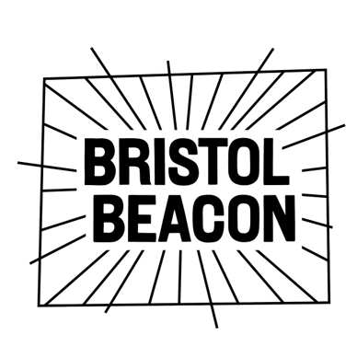
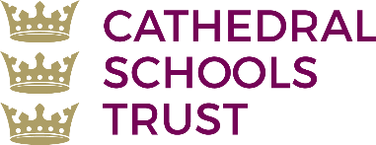


Henleaze Infant School
Music Development Plan 2025-2026: Summary

Overview

This document is a summary of how Henleaze Infant School delivers music education to all our pupils across three areas – curriculum music, co-curricular provision and musical experiences – and what changes we are planning in future years. This information is to help pupils and parents or carers understand what our school offers and who we work with to support our pupils’ music education.

Detail | Information
Academic year this summary covers | 2025 - 2026
Date this summary was published | October 2024
Date this summary will be reviewed | May 2025, June 2026
Name of the school music lead | Charlotte Eskell
Name of local music hub | Bristol Beacon
Name of other music education organisation(s) (if partnership in place) | Bristol Plays Music

Part A: Curriculum Music

This is about what we teach at Henleaze Infant School in lesson time, how much time is spent teaching music and any music qualifications or awards that pupils can achieve.

Reception and Year 1 Curriculum Development

Henleaze Infant School follows the ‘Bristol Plays Music’ curriculum, which is challenging, broad, diverse and inclusive. It is organised into units, each focusing on a musical theme: Rhythm, Pitch, Chronology, Composition or Timbre. The interrelated dimensions of music are embedded through these units, and knowledge is deepened cumulatively over the year groups. We use a range of instruments in composition and use chants and rhymes throughout the curriculum to help embed learning. The school is passionate about singing, and a professional pianist is employed to enrich our singing assemblies and external performances.

We aim to develop a curiosity for the subject, as well as an understanding and acceptance of the validity and importance of all types of music. We are committed to ensuring children understand the importance of music in the wider community and are able to use their musical skills, knowledge and experiences to involve themselves in music, in a variety of different contexts.

Henleaze Infant School dedicates 40 minutes every other week to curriculum music lessons, with an additional 20 minutes per week curriculum time dedicated to singing assemblies. During one term a year, each year group dedicates an additional 30 minutes each week to music to prepare them for a year group performance.

Part B: Co-curricular Music

This is about opportunities for pupils to sing and play music, outside of lesson time, and how pupils can make progress in music beyond the core curriculum.

Choir

Henleaze Infant School choir meets once a week and is for singers in Key Stage 1 . It is offered free of charge and open to all who would like to join. The choir performs at several events throughout the year and is the opening act at the Henleaze High Street Christmas Festival. They also perform to the school, at the local church and at the school May Fair.

Peripatetic Tuition

Piano:
At Henleaze Infant School we offer individual piano lessons to children in Key Stage 1. Lessons are prioritised for children in Year 2 and offered to Year 1 pupils if there is additional space.

Lessons are 20 minutes long and are priced at £15 per lesson. These are paid for in advance each term. Pupil Premium children are given priority space on the waiting list and there is potential for piano lessons to be subsidised via arrangement with the Pupil Premium lead.

Band lessons:
Rock Steady lessons will be held on Thursday and Friday with eight bands consisting of nine children currently running. These sessions are extremely popular and we would encourage early sign-up to ensure a space and preferred instrument choice. Children can play keyboard, electric guitar, bass guitar, drums or vocals and they practise and rehearse as a band for their termly concerts. Sessions are charged at £33.99 per month with a minimum of 33 lessons held across the year.

Part C: Musical Experiences

This is about all the other musical events and opportunities that we organise, such as concerts and shows, and trips to professional concerts.

Singing Assemblies

There is one weekly singing assembly for the whole school. Children sing songs to warm-up and develop the voice, connect to our school values, understand the world around us, and for enjoyment. This time is sometimes used to practise for musical singing events such as the Harvest Festival celebration and the Christmas Carol Concert.

We have a professional pianist that supports the delivery of singing assemblies.

Christmas performances

Children in EYFS perform the nativity to parents and carers each Christmas. This is performed in the school hall on the stage which gives the children experience of performing in front of an audience.

The whole school also congregates at the local church for a Christmas Carol Service. Children in EYFS, KS1 and choir all take it in turns to sing a variety of Christmas and winter songs to parents
and carers alongside readings of the Christmas Story. The audience are also invited to join in with some traditional carols. This event is free for members of the school community to attend.

School productions

All year groups experience working towards and putting on a musical production. These occur three times a year:

- Term 2: EYFS
- Term 4: Year 1
- Term 6: Year 2

The children volunteer for a small or large part and all work together to take ownership of the play by creating props and costumes. The children work hard to rehearse songs and learn their lines. The rest of the school are invited to watch the dress rehearsal of the performance and parents and carers are invited to watch the final performance free of charge.

Collaborative Cathedral Schools Trust Events

As part of the Cathedral Schools Trust, the Year 2 children at Henleaze Infant School are invited to a Celebration of Music day, held every June at Trinity Academy. The children perform as part of a large choir and they rehearse and sing warm ups, partner songs, rounds and performance songs with peers from across the Trust. It is an inclusive and exciting day where our primary musicians see aspirational performances from accomplished secondary musicians. The previous year's visit included watching instrumental performances from Trinity’s Trumpet Ensemble and the Trinity Symphony Orchestra.

There is a small contributory cost towards the coach travel for this event.
The next Key Stage 1 Celebration of Music will be held in Term 6, 2026 with the final date to be decided.

In the Future

This is about what the school is planning for in subsequent years.

Curriculum Music

During the academic year 2026-2027, the Oak National Academy primary music curriculum will be officially launched in Key Stage 1 at Henleaze Infant School. During this academic year (2025-2026), we will trial two of the new units and create new progression documents, curriculum mapping and an intent statement before officially implementing the Oak National Academy Primary Music Curriculum in September 2026.

Next academic year, we will be reviewing the EYFS music curriculum and check the progression is supportive of the KS1 Oak National Academy Curriculum.

Musical Experiences

We are hoping to invite the Henleaze Junior School orchestra to perform at our school to increase the children’s opportunity of listening to live music. It will also give the current Year 2s insight of what is available at Henleaze Junior School when they transition to Year 3.

Further Information

Our local music hub, Bristol Beacon, has a Music Development Plan for 2024-2025 which can be found here.

The link to find further information from the government about Music education can be found here.

